1. In the previous lecture, we split a msg based on a new line into multiple msgs.  
   Let’s use a different logic to split a msg.
2. Reading from CSV file and Splitting based on Comma:  
   
3.   
     
   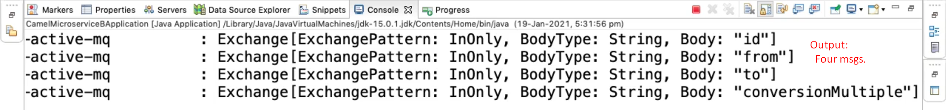
4. Another option to split based on some delimiter is by using some component.  
     
   **Creating a Component (Bean):** **Autowiring the component:** **Configuring the Split Method:** **Output:**